**ENHANCED SOCIAL INTERACTIVITY LEVERAGED BY LOCAL PARTICIPANT DISCOVERY USING A CLOSE RANGE COMMUNICATION SYSTEM**

*U. S. Provisional Patent Application Number 63/861,663. Filing Date 8/11/2025*

**ABSTRACT**

A method is described for enhancing social engagement by discovering potential participants within a geographical proximity using a close range communication system. Users use a computer application, typically on a mobile device, to advertise identifying information to each other via a close range communication service, such as Bluetooth. A group of mutually identified users can then form ad hoc communities of participants that interact in various social activities within the locale of the participants. Online interactions can be enhanced with the opportunity for in-person interactions, leading to more satisfying social outcomes. Social activities might involve gaming, buying and selling, dating, and many more possibilities. Identities could also be authenticated, allowing trust-based transactions to take place.

**Inventors**:

Thomas E. Portegys, DeKalb, Illinois, USA ([portegys@gmail.com](mailto:portegys@gmail.com))

**CLAIMS**

1. A device, typically mobile, equipped a close range communication system that allows users to identify and possibly directly communicate with each other in a local area that is within the range of the communicating system.
2. Together with the above, a centralized or distributed service accessible to the users that allows them to form an ad hoc group to engage in various ways as participants in an enterprise of some sort. The service may take various forms. For example, gaming, buying and selling, and dating are possibilities.
3. The service may also embody an authentication capability that allows trust-based transactions, such as buying and selling to occur.

**BACKGROUND OF THE INVENTION**

Before the advent of remote and online gatherings, local gatherings of people for various purposes were the norm. For example, church attendance was in person for centuries before radio, television and the internet came about. While online interactions can indeed be convenient and efficient, it is believed by social scientists that they lack crucial information channels that in-person interactions provide. For example, social media friends often interact wearing online “masks” that project an inauthentic version of themselves. More pertinently, voice tones and facial expressions are usually lacking in online behavior. These are extremely relevant in interpreting meaning in communications.

This invention seeks to gather participants in activities into situations that can feature both local and online interactions. Users gather in a locale where they can discover each other to participate in various endeavors. Their geographical proximity can foster in-person interactions that enhance their experiences.

*FIELD OF THE INVENTION*

This invention pertains to the fields of close range discovery and ad hoc networks hosting social activities. The social aspect of the invention is how it fosters in-person engagement that enhances participant experiences while simultaneously utilizing the power of internet applications.

*DESCRIPTION OF THE RELATED ART*

US 9264875B2 describes mobile-device proximity discovery enabling users to find others nearby and exchange social data.

US9357352B1alsoallows the discovery of nearby agents via close‑range communication to enable social interactions.

EP1176840A1is about finding social contacts that happen to be nearby. This invention does not specify any particular discovery mechanism, nor the form of the social activities that can be participated in.

The novel aspect of invention, distinguishing it from prior art, is its generality, broadening the scope by fostering the formation of ad hoc groups, diverse interaction types (gaming, dating, commerce), and possible authentication for trust-based activity. The invention sets the groundwork for the implementation of platforms that support a plethora of applications.

*REFERENCES*

US 9264875B2: Location-based discovery of network members by personal attributes for alternate channel communication**.**

US9357352B1: Location-based discovery of network members by personal attributes using dynamic and static location data.

EP1176840A1: Place-specific buddy list services.

**SUMMARY OF THE DISCLOSURE**

The disclosed invention enables enhanced social interactivity by allowing users within close physical proximity to discover each other using a close range communication system, such as Bluetooth. Upon mutual discovery, users may form ad hoc groups through a centralized or distributed online services. These groups can then participate in a variety of social or transactional activities, including but not limited to gaming, dating, and commerce. The system supports identity advertisement and optional authentication features, allowing for trust-based interactions among participants. Unlike prior art, the invention emphasizes the seamless integration of real-world proximity and internet-based platforms, aiming to enrich online interactions through the opportunity for meaningful in-person engagement. The platform is broadly adaptable to various applications without being limited to a specific communication method or social activity type.

**BRIEF DESCRIPTION OF THE DRAWINGS**

FIG. 1 is a diagram of the basic operation of the invention.

**DETAILED DESCRIPTION**

FIG. 1 shows an embodiment in which four users, A, B, C, and D, discover their mutual identities (ID) via a close range communication system. Once discovered, the users can invoke a service that organizes them into a group for some activity. As shown, user A, after receiving user B’s ID, can interact with B via the service. For brevity, only A’s service invocation is shown. Also not shown in this embodiment is a direct interaction between users without the use of a mediating service.

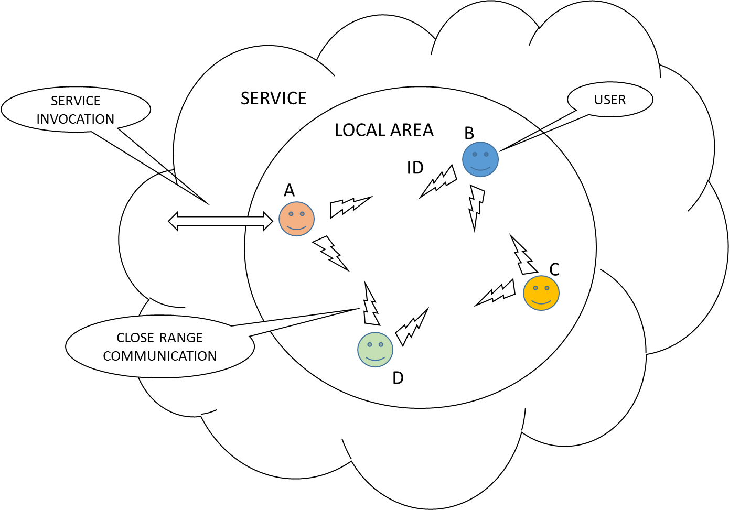

FIG. 1 – BASIC OPERATION